
Notice of Race / Sailing Instructions
Barefoot Sailing Club’s 2019
Dorton Cup
Sunday, November 10, 2019
The annual Barefoot Sailing Club’s Dorton Cup Regatta will be held on Sunday November 10th, 2019. The Dorton Cup Regatta is a closed regatta for Barefoot Sailing Club skippers only, but crew do not need to be members. Although this is a weekend regatta, the results will also be included in the compilation of results for determination of the Barefoot Sailing Club’s “Skipper of the Year”.

- Schedule for Regatta

Sunday, November 10th, 2019

9:00 AM: Skippers Meeting in the parking lot of the Aqualand Marina Ship Store, Flowery Branch, GA.
11:00 AM: Start of the first race Sunday.
~4:00 PM: After Race Celebration (location will be announced at the Skippers Meeting). Starting time for celebration is approximate, subject to the weather, winds, and racing.

- Registration
Registrations will be accepted at the Skippers’ Meeting. There are no fees for registration.
- Location
Chattahoochee Bay and adjoining environs, Lake Lanier, GA
- Rules
The race will be governed by The 2017-2020 Racing Rules of Sailing, the prescriptions of the United States Sailing Association when they apply, except as modified by this Notice of Race.

- Classes and Eligibility
All skippers must be current (2019) members of Barefoot Sailing Club, Inc. All PHRF classes will be eligible to compete. All classes will race together as one fleet. Skippers/boats sailing non-spinnaker must declare as such at the Skipper’s Meeting and will be given an additional 15 second per mile handicap under. BFSC handicap adjustments used for series races will not be used for the Dorton Cup.
- Course
The course for the first race of each day will be posted on the official course board and will be displayed during the skipper's meeting. The location of the islands and permanent marks are indicated on the map shown in Appendix A. All marks or islands must be left either to port or to starboard as indicated on the posted course. Course, Course Length, Base Starting Time, and Short Finish/Motor Time for subsequent races will be posted on the PRO boat and broadcast on VHF (channel to be posted at skipper’s meeting). PRO boat will display the “L” Come within Hail  flag and the Second Substitute  pennant.

- Marks
Permanent marks are either Corps of Engineer marks or Lanier Area Racing Council (LARC)/Lake Lanier Sailing Club (LLSC) permanent marks. If temporary marks are used, the marks will be orange tetrahedrons (pyramids) or any other device as decided by the racing authority.
- The Start
The Races will be started using the staggered start (pursuit race) system.

Each boat will have its own specific start time as determined by each boats specific PHRF rating and course length. Course length and start times will be obtained as outlined in section 6 Course. PDF file containing table for start times provided on the BFSC Racing web page. Link provide here: Pursuit Handicap Table.pdf. Each skipper should have a copy of the start time tables on board in order to determine start times for races after the first race of the day.

All starts are based on the honor system as no race committee is usually on station to monitor and police the starting sequence.

The Starting Line is an imaginary line that extends no further than 20 yards and is perpendicular to the first mark. For a proper start, you must start within 20 yards of the proper side of the starting mark as indicated on the official course board.

Boats that are not starting should keep clear of the starting area as to not interfere with those that are starting.

It is the responsibility of each skipper to synchronize his or her own starting watch with that of the official starting clock displayed at the skipper's meeting.

- The Finish
All finishes are based on the honor system as no race committee is usually on station to monitor and police the order of finish.

The Finish Line is an imaginary line that extends no further than 20 yards and is perpendicular to the last mark. For a proper finish, you must end your race within 20 yards of the proper side of the finishing mark as indicated on the official course board.

As part of the published course, one mark will be determined to be the short finish mark along with a designated time.

The short finish will be used to score the race if the top three lead boats (this is a change from the RRS Rule 90.3 a) do not complete the full course by the predetermined time (motor-up time). Note: The rules for a proper finish still apply to a "Short Course" finish. All skippers should take and record their short finish time for each race.

In the event a race is shortened, the order of finish will require adjusting as start times were based on a course with a longer distance.

All skippers are responsible for keeping up with their own finish times. Once again, this is based on the honor system. Skippers are responsible for providing both their start and finish times at the Dirt Up after the races.

- Minimum Wind Speeds and Time Limit
The Race Committee will not attempt to start a race if they judge the wind to be less than three miles per hour (mph) over the course area. Should Race Committee deem there is not enough wind to start a race, the Postponement pennant will be displayed along with two short horn bursts. Pennant will be displayed at the race start time. At each 15 minute interval, Race Committee will reassess wind conditions. If an additional delay is warranted, two short horn signals will again be given. Postponement pennant will remain flying. If Race Committee determines there is enough wind to start racing, the Postponement pennant will be lowered with one short horn burst. Racers will adjust their start time base on 15 minute delay intervals. (For example: A boat which hand an original start time of 11:06:28 AM, would have a start time of 11:36:28 AM if the Postponement pennant is lowered at 11:30 AM.)

As part of the published course, a motor-up time will be determined. If a boat does not finish the entire race by the predetermined time, the race is over for that skipper and the boat will receive a Did-Not-Finish (DNF) for the race. The “entire race” being either the full course or the shorten course as determine by conditions stated in the “Finish” section.

- Scoring
All races will be scored using the US SAILING Performance Handicapping Rating Formula, Time on Distance (PHRF TOD).
- Protests
Competitors must notify the Race Committee of their intention to file a protest at the end of a race in which the incident occurs and before the warning signal for the next race, or within two hours, whichever is shorter. The Race Committee Chairperson must receive written protests within two hours of the end of the last race for the day. The RC Chairperson will convene a Protest Committee which may consist of members of the Race Committee and/or participants in the Regatta.
- Number of Races
Weather permitting, up to three (4) races shall be attempted. One (1) race shall constitute a series. If four or more races are held, there will be one "throw out"; if there are three or fewer races, all races will be utilized to tabulate the final ranking for all boats.
- Prizes
Results will be calculated at the “After Race Celebration”. At the annual BFSC Banquet, trophies will be awarded for First, Second and Third places. The perpetual trophy will remain in the possession of the first place winner until the next Dorton Cup event.

DISCLAIMER OF LIABILITY
Sailing is an activity that has an inherent risk of damage and injury. Competitors in this event are participating entirely at their own risk. See RRS 4, Decision to Race. The race organizers (organizing authority, race committee, protest committee, host club, sponsors, or any other organization or official) will not be responsible for damage to any boat or other property or the injury to any competitor, including death, sustained as a result of participation in this event. By participating in this event, each competitor agrees to release the race organizers from any and all liability associated with such competitor’s participation in this event to the fullest extent permitted by law.
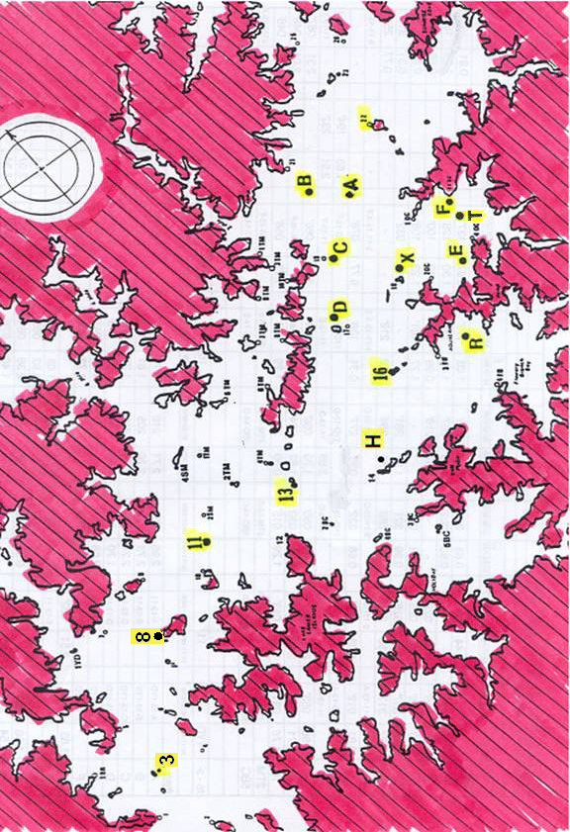
Appendix A – Racing Area Map

