Barefoot Sailing Club
2022 Spring Series
Sailing Instructions
Revised 03/03/2022

1. Rules
Rules shall be governed by “the Rules” as defined in the Racing Rules of Sailing (RRS).

2. Notices to Competitors
Notices to competitors will be published on the Barefoot Sailing Club WWW site (http://www.barefootsailingclub.org), which is the official notice board.

3. Changes to Sailing instructions
Any changes to sailing Instructions will be published on the official notice Board within 24 hours before any scheduled race. In addition, the Race committee has at its disposal an official clipboard for publishing notices that apply to daily activities.

4. Schedule of Races
Spring Series 1 Sunday March 13, 2022. Skippers Meeting 11:00, Race start at 13:00
Spring Series 2 Sunday March 20, 2022. Skippers Meeting 11:00, Race start at 13:00
Spring Series 3 Saturday April 16, 2022. Skippers Meeting 11:00, Race start at 13:00
Spring Series 4 Sunday April 24, 2022. Skippers Meeting 11:00, Race start at 13:00
Spring Series 5 Saturday April 30, 2022. Skippers Meeting 11:00, Race start at 13:00
Spring Series 6 Sunday June 5, 2022. Skippers Meeting 11:00, Race start at 13:00
Spring Series 7 Sunday June 26, 2022. Skippers Meeting 11:00, Race start at 13:00
Spring Series 8 Saturday July 16, 2022. Skippers Meeting 16:00, Race start at 18:00

5. Fleets and PHRF Requirements
There will be two fleets for the BFSC Spring Series. They will consist of the Auxiliary PHRF Racing and PCRF Cruisers. For races combined with LARC, boats will race with LARC PHRF and fleet definitions. BFSC results will be adjusted as needed. The Barefoot series races will continue to use pursuit starts. BFSC will divide the racers into two fleets; PHRF Racing Fleet and PCRF Cruiser Fleet.

The following rules will be used to determine which fleet you belong in:
Racing Fleet:
- Any multihull or planing hull boat.
- Any boat using a spinnaker.
- Any boat registered as non-spin will have their PHRF number increased 15 seconds

Cruiser Fleet:
- Any boat with a displacement hull and with a fixed keel, Dacron sails, permanent head, fixed galley, and interior cushions.

All fleets:
- All boats must have a valid PHRF Rating Certificate issued by the Lake Lanier PHRF Committee.

6. Racing Area
The racing area will be determined and announced at the skipper's meeting.

7. Course
BFSC does have a group of courses that are predefined. If conditions are suitable for one of the defined courses, the course will be announced at the skipper’s meeting. A sheet with the predefined courses will be available for each skipper. If none of the predefined courses are fitting for the day, a course will be posted on the official course board and will be displayed during the skipper's meeting. The location of the islands and permanent marks are indicated on the map shown in Appendix A. All marks or islands must be left either to port or to starboard as indicated on the posted course.

8. Marks
Permanent marks are either Corps of Engineer marks or Lanier Area Racing Council (LARC)/Lake Lanier Sailing Club (LLSC) permanent marks. If temporary marks are used, the marks will be orange tetrahedrons (pyramids) or any other device as decided by the racing authority.

9. The Start
The Races will be started using the staggered start system (pursuit race).

Each boat will have its own specific start time as determined by each boat’s specific PHRF rating and course length. Course length will be obtained at the skipper's meeting. Start times based on length can be obtained at skipper’s meeting. PDF file containing a table for start times can be found on the BFSC web page (Under the Racing->Barefoot Racing section, first paragraph).

All starts are based on the honor system as no race committee is usually on station to monitor and police the starting sequence.

The Starting Line is an imaginary line that extends no further than 20 yards and is perpendicular to the first mark. For a proper start, you must start within 20 yards of the proper side of the starting mark as indicated on the official course board.

Boats that are not starting should keep clear of the starting area as to not interfere with those that are starting.

It is the responsibility of each skipper to synchronize his or her own starting watch with that of the official starting clock provided at the skipper's meeting.

10. The Finish
All finishes are based on the honor system as no race committee is usually on station to monitor and police the order of finish.

The Finish Line is an imaginary line that extends no further than 20 yards and is perpendicular to the last mark. For a proper finish, you must end your race within 20 yards of the proper side of the finishing mark as indicated on the official course board.

As part of the published course, one mark will be determined to be the short finish mark along with a designated time.

The short finish will be used to score the race if the top two lead boats (this is a change from the RRS Rule 90.3 a) do not complete the full course by the pre-determined time (motor-up time). Note: The rules for a proper finish still apply to a "Short Course" finish. All skippers should take and record their short finish time for each race.

In the event a race is shortened, the order of finish will require adjusting as start times were based on a course with a longer distance.

All skippers are responsible for keeping up with their own finish times. Once again, this is based on the honor system. Skippers are responsible for providing both their start and finish times to the designated Race Committee for that race.

11. Minimum Wind Speeds and Time Limit
The Race Committee will not attempt to start a race if they judge the wind to be less than three miles per hour (mph) over the course area. Should Race Committee deem there is not enough wind to start a race, the Postponement pennant will be displayed along with two short horn bursts. Pennant will be displayed at the race start time (1:00 PM, 2:00 PM or 6:00 PM). At each 15-minute interval, Race Committee will reassess wind conditions. If an additional delay is warranted, two short horn signals will again be given. Postponement pennant will remain flying. If Race Committee determines there is enough wind to start racing, the Postponement pennant will be lowered with one short horn burst. Racers will adjust their start time base on 15-minute delay intervals. (For example: A boat which hand an original start time of 6:06:28 PM, would have a start time of 6:36:28 PM if the Postponement pennant is lowered at 6:30 PM.)

As part of the published course, a motor-up time will be determined. If a boat does not finish the entire race by the predetermined time, the race is over for that skipper and the boat will receive a Did-Not-Finish (DNF) for the race. The “entire race” being either the full course or the shorten course as determine by conditions stated in the “Finish” section.

12. Withdrawal
Boats withdrawing from a race should notify the Race Committee as soon as possible.

13. Scoring
Races will be scored using the PHRF rating system using the time-on-distance formula. A valid PHRF certificate is required of each boat to be scored for series standings.

The Low Point System of RRS Appendix A will be used. Ties will be broken in accordance with A8. Points will be awarded as follows (this changes A4.2):

Finish Points

First 1
Second and Subsequent Place
DNF Starters in race + 1
DSQ or OCS Starters in race + 1
DNC Entrants in series + 1

One throw-out will be applied if six races in the series are sailed. This is a change from the RRS Appendix A2.

14. Protests
In addition to the requirements of RRS 61, a protesting boat shall notify the Race Committee of its intent to protest within 2 hours of the conclusion of the race in which the incident occurred. This changes RRS 61. PROTEST FORMS are available on the race committee boat or may be attained via www.ussailing.org website. Written protests shall be postmarked or e-mailed no later than the Monday following the race, to the BFSC Racing Captain (fkempner@hotmail.com or pwinham@gmail.com ), who will notify all involved parties of the date and time of protest hearing.

15. Awards
After each race, small pennants will be awarded to the first, second and third place winner. Series awards shall be made to the top BFSC member finisher for both fleets based on cumulative total of points in all the races of the series as stated in the Scoring section. If necessary, one completed race shall constitute a series.

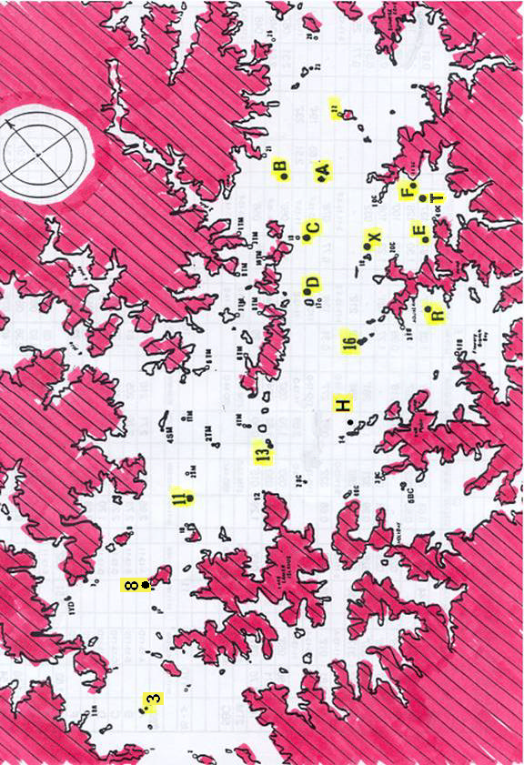
Appendix A – Racing Area Map

